Parth Babbar

Retail banking operations in us

**Introduction:**

Retail banking, often known as consumer banking, is the providing of services by a bank to individual customers rather than businesses, corporations, or other banks. Savings and checking accounts are available, as well as mortgages, personal loans, credit cards, and certificates of deposit.

**Key Components:**

1. **Account Management:** Checking accounts are perfect for daily financial activities since they allow you to write checks, use your debit card, and pay bills online. They allow simple access to finances for daily costs. Savings accounts, in contrast, are meant for amassing cash and earning interest, with fewer transactions than checking accounts. Certificates of Deposit (CDs) are time deposits that pay fixed interest rates and require funds to be placed for a certain period of time, resulting in a predictable return upon maturity. Each of these financial products has a unique function, catering to different financial objectives and demands.
2. **Lending Services:** Personal loans, mortgages, and credit cards are important financial tools that cater to a variety of requirements and situations. Personal loans, which are often unsecured, allow individuals to borrow money for personal costs such as medical bills or house upgrades without the need for collateral. Mortgages, on the other hand, are secured loans used to purchase property, with long-term repayment schedules that make house ownership possible. Credit cards offer revolving credit lines for ordinary expenditures, allowing users to carry balances and pay interest, giving them greater flexibility in managing their costs. These financial products work together to serve a wide range of financial goals, including emergency necessities, long-term investments, and day-to-day expenditures.
3. **Payment & Transaction Services:** Debit and credit cards are payment cards that are linked to bank accounts or revolving credit lines, providing easy access to cash and allowing global purchases. Online banking platforms offer digital capabilities for account management, bill payment, and money transfers, increasing user convenience and accessibility. Mobile banking brings these services to smartphones via dedicated applications, allowing users to execute financial transactions on the move with ease. Together, these technologies transform how people handle their money, providing flexibility and efficiency in regular banking operations.
4. **Wealth Management & Advisory Services:** Investment services include mutual funds, stocks, bonds, and retirement accounts, which allow people to build wealth and diversify their portfolios. Financial planning provides personalised assistance on asset management, retirement plans, and tax optimisation, resulting in bespoke solutions to suit individual financial objectives. Together, these services enable people to make educated decisions and successfully safeguard their financial destiny.  
   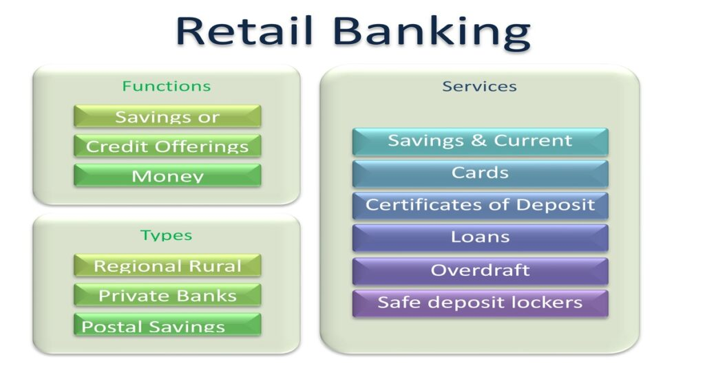

**Technology Innovations in Retail Banking:**

1. **Online and Mobile Banking:** Rapid development owing to convenience and accessibility.
2. **Artificial Intelligence (AI):** Chatbots are used to provide customer care, identify fraud, and provide personalised financial advice.
3. **Blockchain Technology:** Increases transaction security and efficiency.
4. **Fintech Partnerships:** Working with financial technology companies to provide new goods and services.

**Regulatory Departments:**

Retail banks in the United States are subject to severe regulations to guarantee stability and customer protection. The key regulatory bodies include:

1. Federal Reserve System (Fed)
2. Office of the Comptroller of the Currency (OCC)
3. The Federal Deposit Insurance Corporation (FDIC)
4. The Consumer Financial Protection Bureau (CFPB)

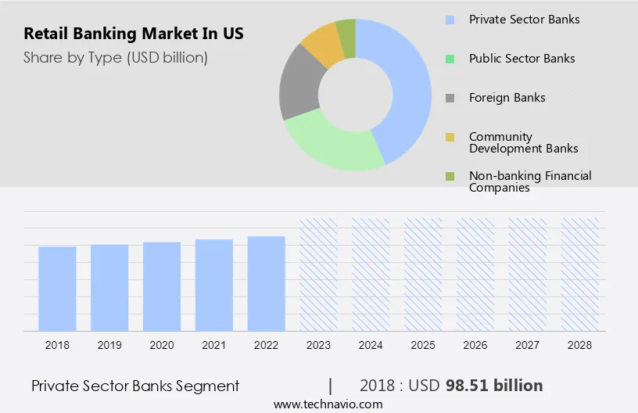

**Market:**

1. **Major Players:** JPMorgan Chase & Co., Bank of America, Wells Fargo & Co., Citigroup Inc. & US Bancorp  
   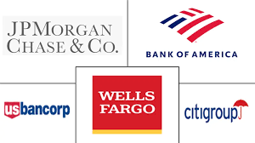
2. **Marketing Trends:**   
    1.Digital banking is becoming increasingly popular.  
    2.Rise of neobanks and digital-only banks.  
    3.Increased emphasis on the client experience and personalised banking.  
    4.Expansion of financial inclusion efforts.

**Statistics:**

1. **Revenue:** Retail banking is a key income source for banks, frequently accounting for more than half of overall revenue for big banks.  
   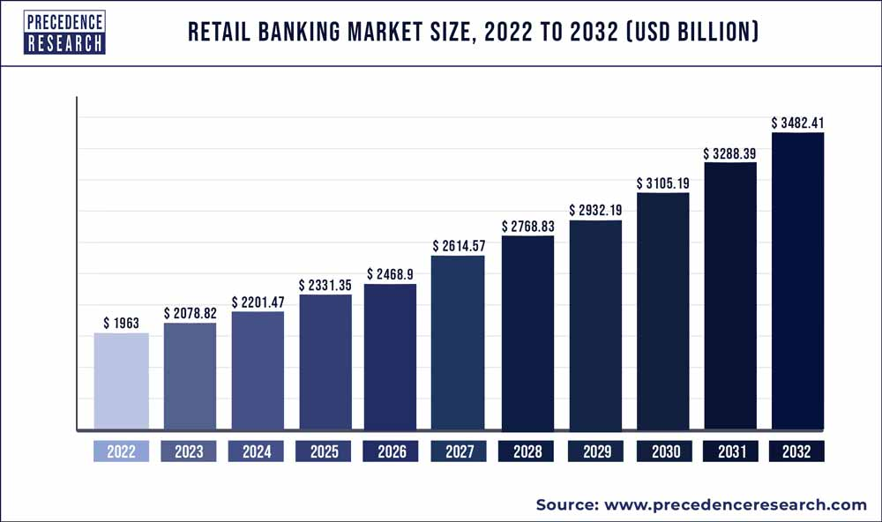
2. **Loan Growth:** In 2023, all loans and leases at US commercial banks were estimated to be worth $16.23 trillion.
3. **Deposit Growth:** Commercial banks' total deposits were around $17.34 trillion in early 2023.  
   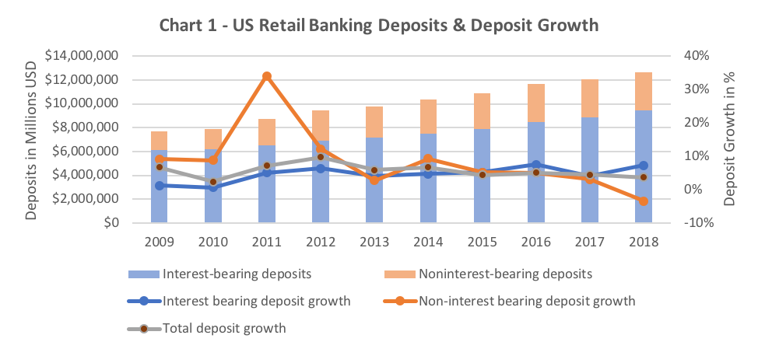
4. **Mobile Banking Usage:** By 2022, 80% of US consumers reported using internet banking, with 48% using mobile banking applications.
5. **Branch Decline:** The number of bank branches is reducing as a result of digital transformation. In 2022, the US had roughly 72,000 bank branches, a decrease from 95,000 in 2010.

**Conclusion:**

Retail banking in the United States is a vibrant and changing industry, characterised by fast technical improvements and a robust regulatory environment. Banks are increasingly focused on digital transformation to satisfy clients' evolving demands, providing a mix of classic and new financial services. While concerns like as cybersecurity risks and regulatory compliance remain, the industry nonetheless offers potential for development and innovation.